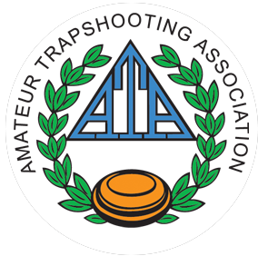June 6, 2019
July 4 or 5, 2019
August 8, 2019

* Shooting time: 10:00 – 7:00
* 50 target program-Event 1- Singles, Event 2- Handicap, Event 3- Doubles.
* Shoot one, two or all events but may only Shoot 1-single, 1-handicap, and 1-doubles event per day.
* Targets will be ATA registered.
* Must be ATA member to participate.
* New shooters joining ATA for first time
will join for free for the 2019 shoot year.
* There will be a daily ATA fee of $1.50
* OSATA State fees will be $1.00.
* ATA rules will govern these events.
* 50-bird target fee will be $10.00 per event. Shoot card OK.
* Must have a minimum of 3 shooters in each event to register the targets.
* Targets may be cross registered with the PITA upon payment of appropriate fees.
* Cross registered fee will be $4.00 to PITA and 2 cents per target to OSTA.
* Contact info – John Spindler 541-460-2441

