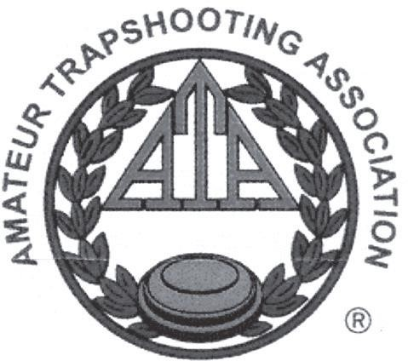
Bend Trap Club
29753 E Highway 20
Bend, OR 97701

The Bend Trap Club
Invites you to the

2020 Oregon ATA
Southern Zone Shoot
March 28, 2020

300 ATA Registered Targets
200 Singles
100 Handicap

The Bend Trap Club has been selected by the OSATA Directors in the Oregon Southern Zone to be the host for the Third Annual Oregon Southern Zone Trapshooting Championships.

The Bend Trap Club welcomes you to the
2020 ATA Oregon Southern Zone
Trapshooting Championships
- Come and shoot over voice release Pat traps and White Flyer orange dome bio targets.
- The club will open at 12 p.m. on Friday, March 27, for practice and squadding. Kitchen will be open Saturday.
- RV parking with power and water is available. Please check in w/cashier.
- PITA cross registration is available. Shooter must be current PITA member.
- Bend Trap Club and Directors will not be responsible for any accidents or loss of property.
- Bend Trap Club reserves the right to change this program in whole or in part at any time without notice.
- Please contact Julie Spindler at 541-480-4576 or osatasecretary@gmail.com for information and squadding.
We appreciate your attendance and look forward to seeing you at this fun shoot. Thank you.
Good luck and good shooting
Your friends at the
BEND TRAP CLUB
Richard Shrode, President

ATA Registration Certificate

This certifies the Bend Trap Club has been authorized to hold a registered shoot at Bend, Oregon on March 28, 2020. ATA rules shall govern this shoot and all scores shall be included in the official records of the Amateur Trapshooting Association.
Hunter Galloway III, Secretary

Oregon Southern Zone Singles Championship
Saturday, March 28th, 10:00 AM
Events 1 & 2
100 Targets each event
Four Classes A, B, C, D

Daily ATA Fee (on first event of the day) $3.00

Target & Trophy Fee $34.00
OSATA Southern Zone Fee $2.00
Lewis Class (3 Classes, 100%) $10.00

$10.00 of each entry will create a cash purse. Each class
shoots for its own money, paid 100%. If 9 or more entries are in a class, purse will be split 60/40 high gun.

Trophies will be awarded on total 200 targets to Champion and each class winner. Thank you, Chuck Haas for your generous donation.

The top five Southern zone resident shooters on 200 targets who attend the State Shoot will represent the Oregon Southern Zone in the Zone Team competition at the 2020 ATA State Shoot in Hermiston.
Event 3
Oregon Southern Zone Handicap Immediately following event 2
100 Targets | $32.00
Target & Trophy Fee $34.00
OSATA Southern Zone Fee $2.00
Lewis Class (3 Classes, 100%) $10.00
OSATA Magnums $18.00

$4.00 of each entry will be awarded to the Champion.
$6.00 of each entry will create a purse for 2nd, 3rd, and 4th place to be paid 50/30/20 high gun.

